Program introduction letter
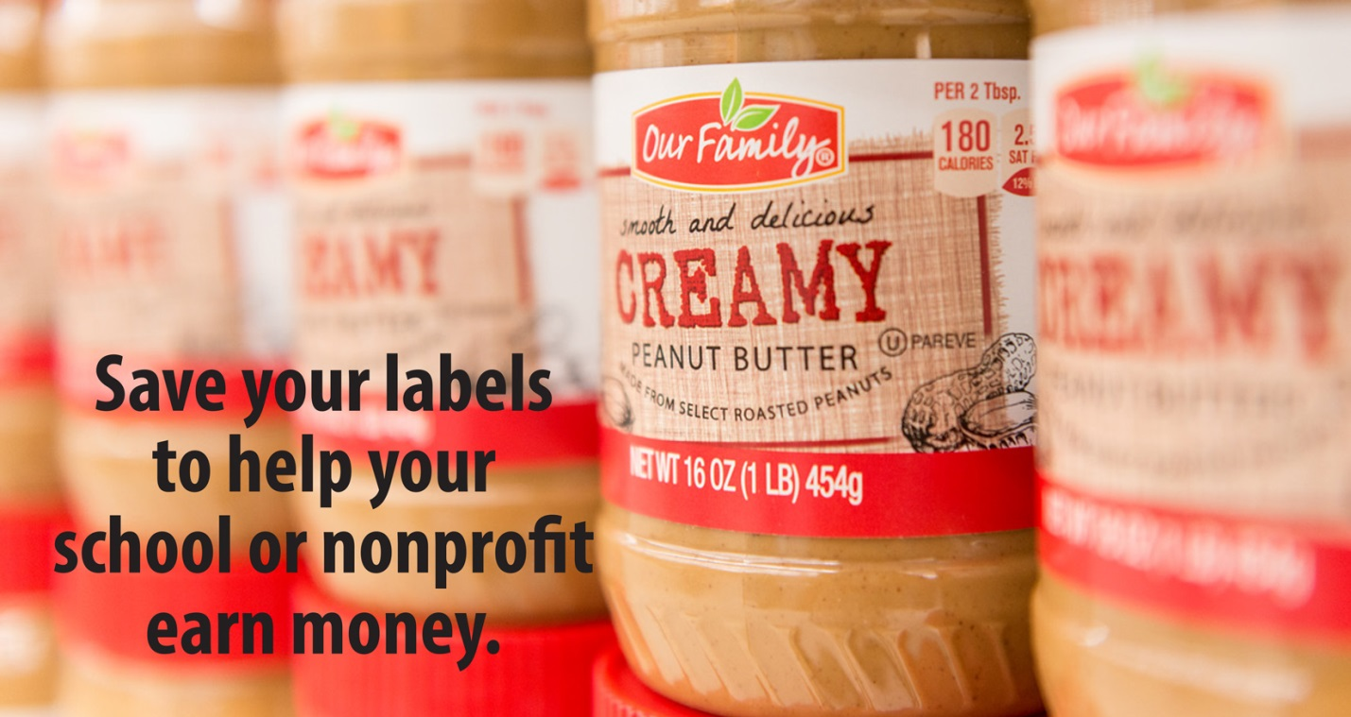

Dear _________________,

<Nonprofit organization name> is participating in the Our Family® Direct Your Labels™ program, and we hope you will help us as we collect UPC barcodes from all your favorite Our Family brand products.

Each time we collect 500 UPC barcodes, we can turn those labels into $25 for our nonprofit organization. And with more than 1,400 retail grocery stores across the country participating in the program, it’s easy to turn Our Family labels into cash for <nonprofit organization name>!

To participate in the Direct Your Labels program, simply clip and save the UPC barcode on every Our Family brand product you purchase at <insert local store names>. For every 500 UPC barcodes we collect, we will earn $25 from SpartanNash, the company that makes and distributes the more than 2,000 Our Family® brand products with national brand quality at a lower price. With your support – and your labels – we’ll be raising money to purchase <items needed>.

If you aren’t able to drop your UPC barcodes off in person, you can also mail them to <address>. We do need original Our Family labels to earn the $25, so please no photocopies.

Thanks to the Direct Your Labels program, we can raise money for <nonprofit organization name> as we shop for our groceries each week. Start saving those UPC barcodes! We’ll continue collecting them throughout the year.

Sincerely,

<Point of contact>
Sample newsletter article
Start saving your Our Family® UPC barcodes! We’re raising money to <send our government class to Washington, D.C.> through Direct Your Labels™

At the end of the year, <Allendale High School> will send our <10th grade government class to Washington, D.C. for a five-day field trip>. To offset the cost of this event, we are participating in the Direct Your Labels™ program, made possible by SpartanNash.

Through the Direct Your Labels program, we can raise money simply by doing something we all do each week – going to the grocery store.

Every time you shop at any local store carrying Our Family brand products, clip and save your UPC barcodes – and encourage your friends and family to do the same. Every time we collect 500 UPC barcodes, we can turn them into a $25 check for <Allendale High School>! And with your support and more than 2,000 Our Family brand products available to purchase, there’s no limit to the amount of labels we can collect as we work toward our goal of <$500>.
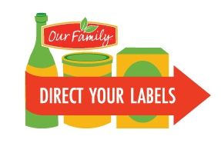
To make it easy for parents, families and school supporters to turn in their Our Family barcodes, we’ll be collecting product labels in our Direct Your Labels box. The box has the DYL logo on it, and it’s located at the <entrance to our building>. Please make sure you drop off the original UPC barcodes – that’s how we earn our $25 checks.

If you aren’t able to drop your labels off in person, you can also mail them to <Coordinator’s name, 5943 Penny Farm Dr., Kentwood, MI 49508>.

Through the Direct Your Labels program, we can turn YOUR Our Family Labels® into cash for OUR <students to experience all that our nation’s capital has to offer>!

Suggested social media posts
Sample #1
Help <nonprofit name> earn money through the Direct Your Labels program! We’re collecting Our Family® labels to <fundraising goal>. For every 500 labels we collect, we will earn $25 – and there’s no limit to the number of times we can earn the reward. Drop your UPC barcodes off at <collection location>.

Sample #2
<Nonprofit organization name> has the opportunity to earn $25, simply by collecting Our Family® UPC barcodes. Through the Direct Your Labels™ program, we can turn Our Family labels into cash for our organization!

With your support – and your Our Family® labels – we’ll be raising money to purchase <items needed>.

